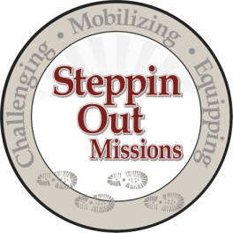

Disaster Response Packing List

* Listed below are some of the items that we are aware of that you will need to pack.
* Please DO NOT over pack, but be prepared for at least one week's worth of clothing.
* There will be limited laundry services available for those staying more than one week.
* The temps have been in the high 90’s to low 80’s at night and equal humidity.
* We will be housed in the church Sunday School annex building. Groups of 5-6 per room.
*Please note - there is NO housing available for families or husband/wife teams to room together.

- Cot/air mattress – (twin size works real well for the floor space we have to work with)
- Sleeping bag (optional)
- Sheets/pillows
- Towels/washcloths
- Mosquito spray/repellent – this is not a must, but you can bring it along.
- Personal Toiletries
- Flashlight/batteries
- Gloves – Work and/or rubber
- Boots – Work and/or rubber
- Work clothes
- Shorts/sleeping shorts
- Shower shoes (flip-flops)
- Extra shoes/slippers to wear in the church while we are at “home”.
- Personal tools - tool apron/hammer/screwdriver/wrench/tape-measure/battery drill/

The project will consist of dry-wall (some removal, hang and taping), possible roof repair, basic electric, plumbing, finish work/trim, flooring, etc.

Cost - $150.00 per person (due upon arrival) – this will cover all meals, church use and transportation to/from the job site. Any other meals, snacks, during travel will be assumed by the person. Walmart/Target and Grocery stores are readily available for anything you might have forgot or need.

SOM Contact information: Shirley/Office - (330) 852-7855 shirley@somissions.com

Emergency Contact info: John’s cell (330) 407-0860 john@somissions.com / Joel's cell (330) 407-0422 joel@somissions.com / Joe Linden - (330) 416-2729 joe@somissions.com

Host Church in Louisiana - Community Bible Church 8354 Jefferson Highway Baton Rouge, Louisiana 70809
(225) 924-1369 secretary@cbcla.org

Visit their website and click the link - "Flood Recovery" for a map and directions. http://516church.com/

